Hardik Shah Roll no. 25, Div: D2

1. **Write a C program to print hollow rectangle square patterns. Take r and c from the user.**

**\*\*\*\*\*\*\*\*\*\*\***

**\*                 \***

**\*                 \***

**\*                 \***

**\*\*\*\*\*\*\*\*\*\*\***

Code:

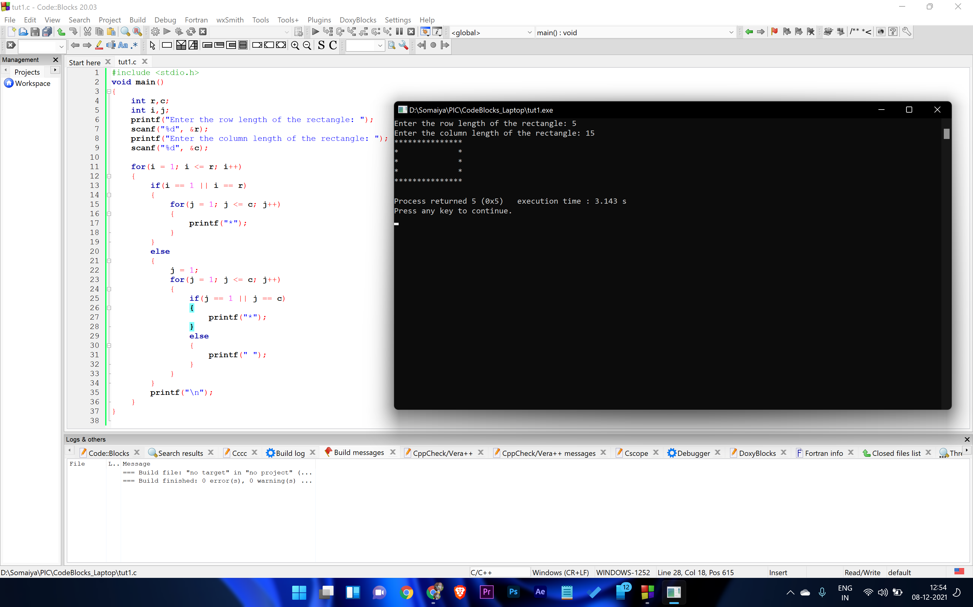

1. **Write a C program to print the following pattern.**

**5432\***

**543*1**

**54*21**

**5*321**

**\*4321**

Code:

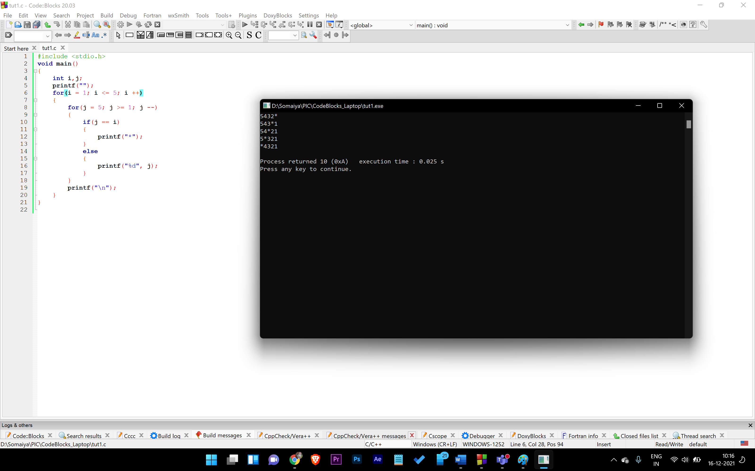

1. **Write a C program to compute the EMI amount for a customer’s purchase on loan using switch control.**

**No. of Years                                EMI**

**1                                      10%**

**2                                      11%**

**3                                      12%**

**4                                      14%**

1. **15%**

Code:

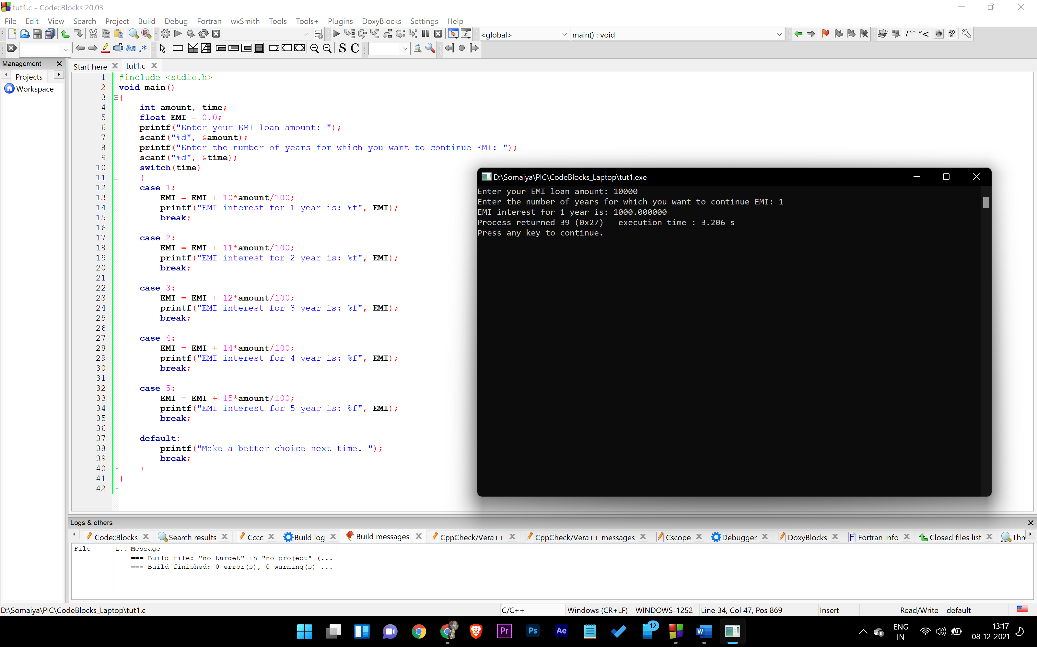

1. **Get the lengths of three sides of a triangle. Check whether the triangle can be formed or not. If possible then calculate the area of triangle.**

**(Hint: Use Hero’s formula for calculating the area of the triangle. Use c library(math.h) function sqrt() for calculating square root value)**

Code:

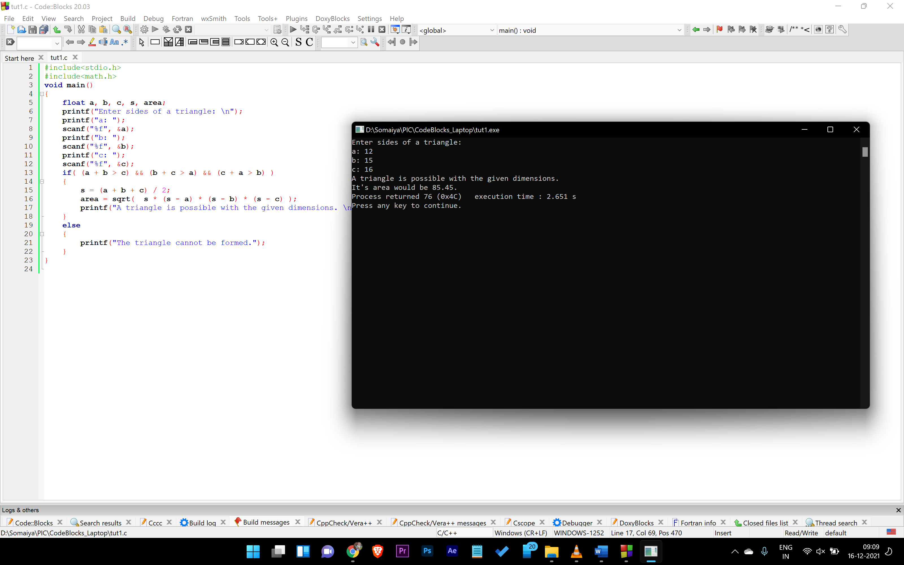

1. **A garment shop is offering a discount as given for the festive season.**

**On purchase above Rs 5000/- flat 10 % discount**

**On purchase above Rs 10000, discount of 15 %.**

**For customers having membership card there is regular discount of 10 %**

**At no time the total discount is more than 20 %**

**Write a program which calculates the discount offered and amount to be paid by customers with details as follows**

**Customer with purchase of Rs 12,300/- having no membership card**

**Customer with purchase of Rs  7,990/- having membership card**

**Customer with Purchase of 14,600/- having membership card.**

**Program should input the purchase amount and status of the membership card from the user.**

Code:

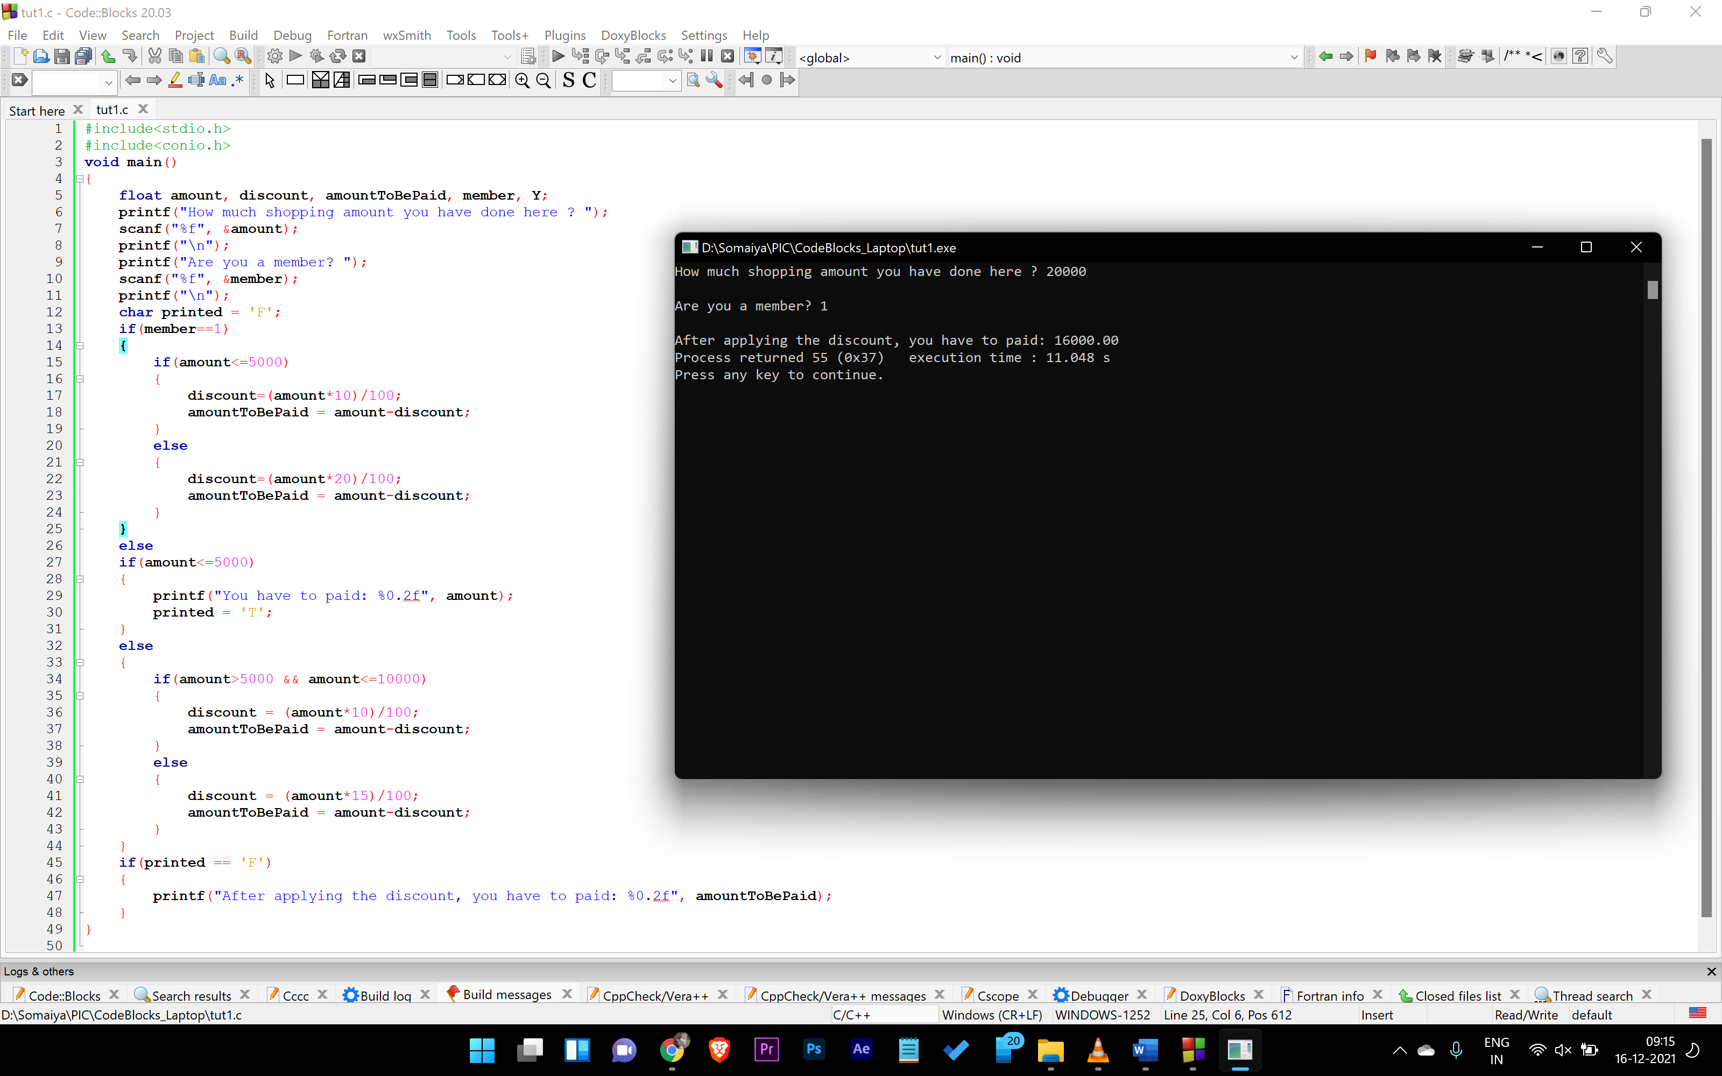

1. **WAP to find GCD of two numbers**

Code:

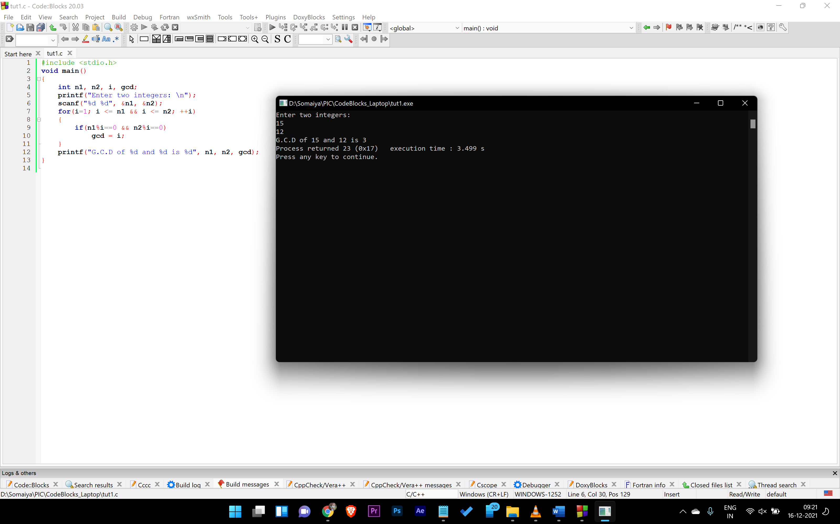

1. **WAP to calculate the value of the following series.**

Code:

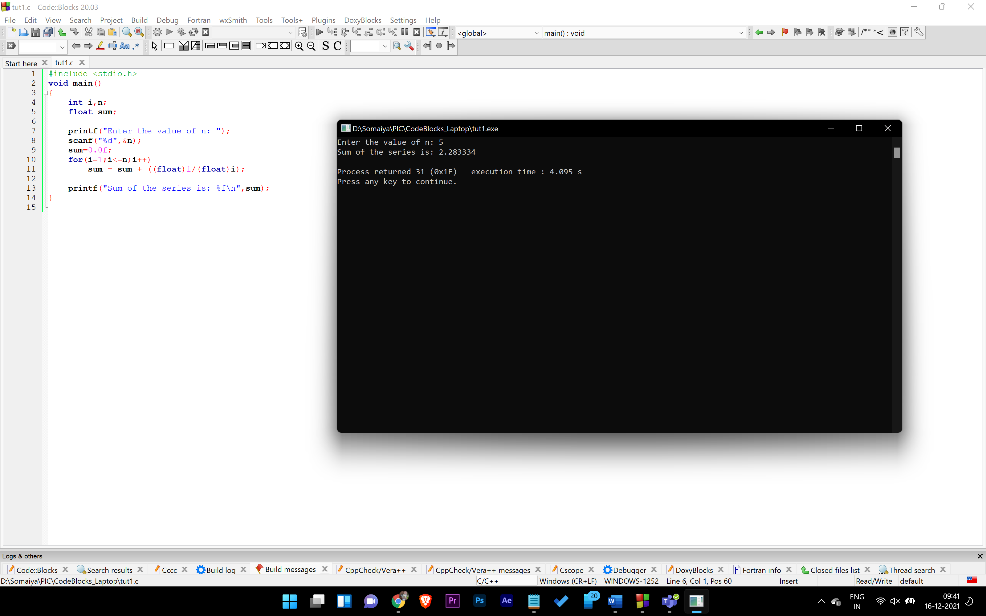

**b.)**

Code:

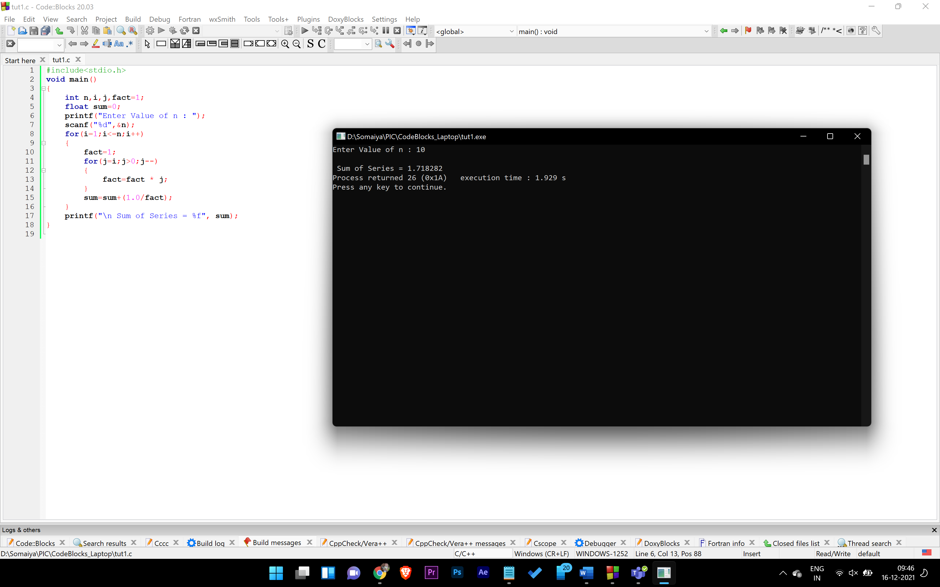

1. **WAP to display fibonacci series in pattern printing method**

**Ex: n = 6**

**0**

**0 1**

**0 1 1**

**0 1 1 2**

**0 1 1 2 3**

**0 1 1 2 3 5**

Code:

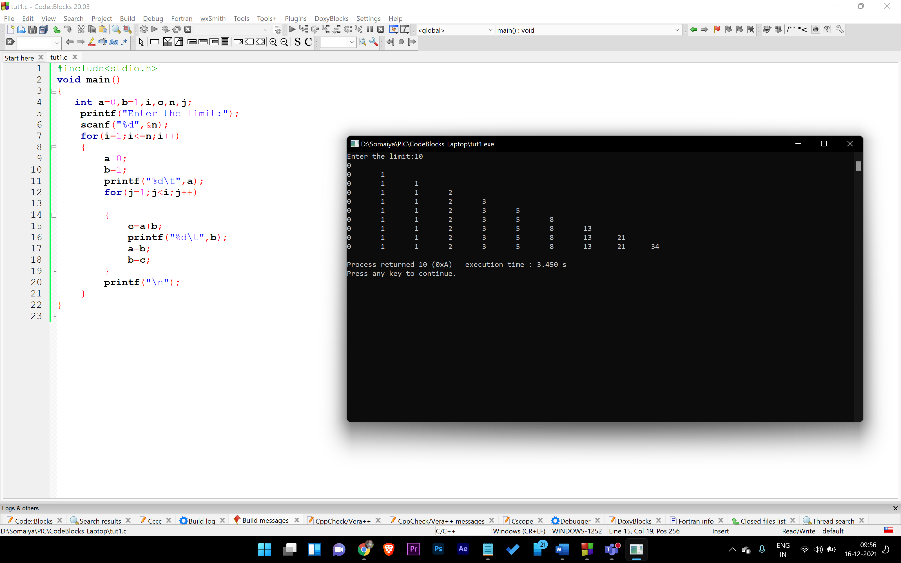

1. **WAP to print following pattern:(Note: No of line specified by user)**
   1. 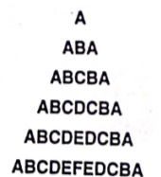

Code:

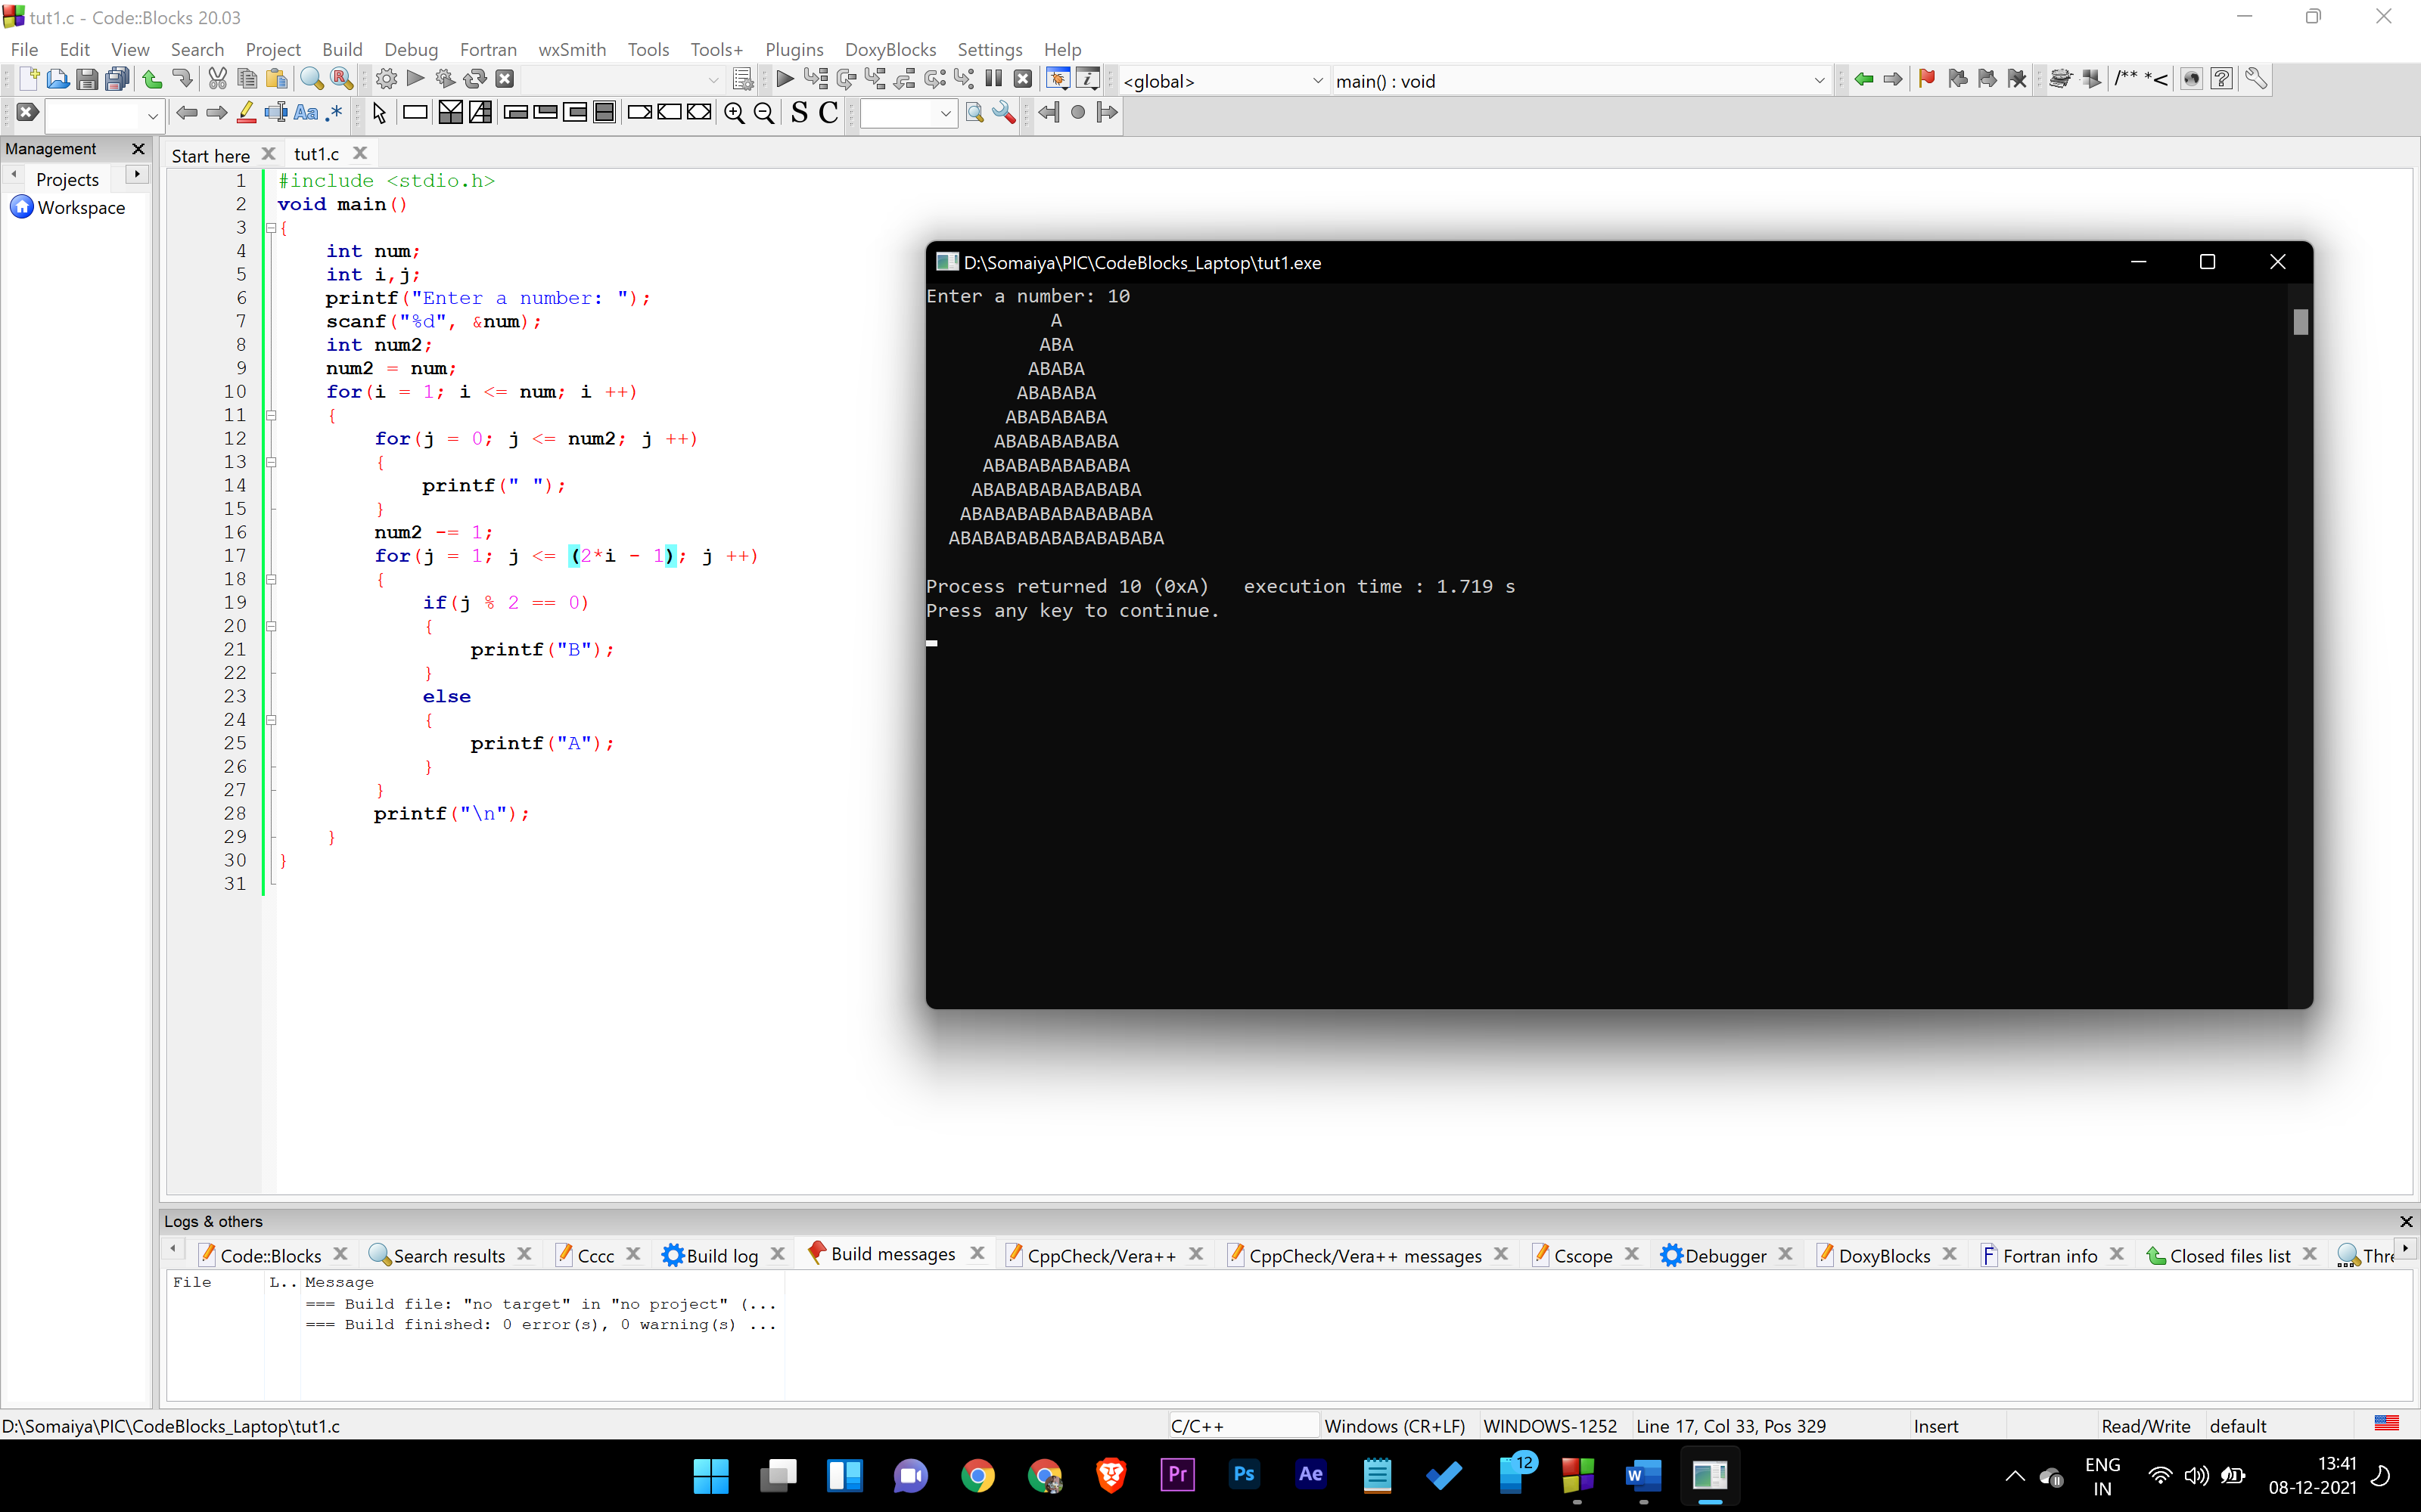

* 1. 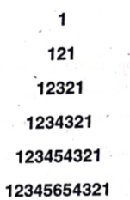

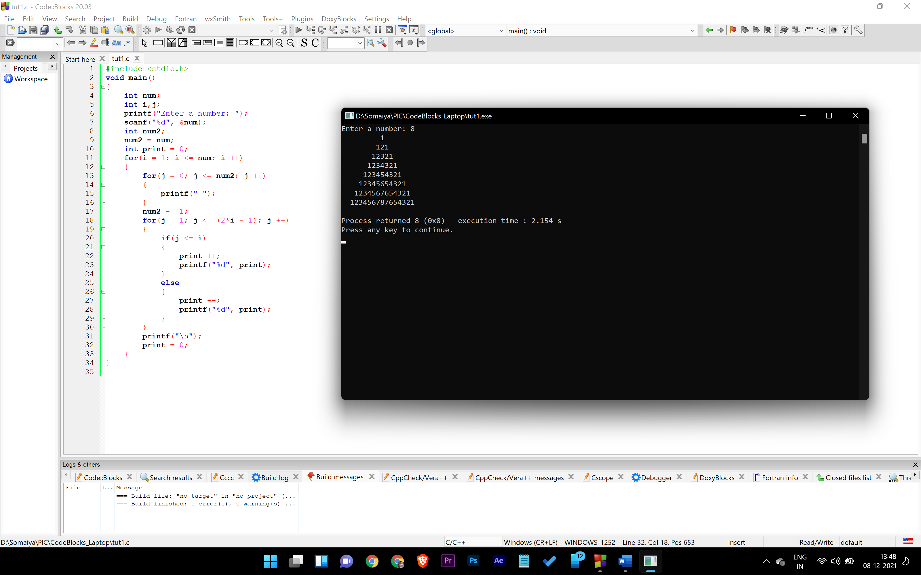

1. **Write a program to express given no as a addition of two prime numbers print all the possible combination**

**For eg.**

**Input no is 26**

**26= 3+23**

**26= 7+19**

**26= 13+13**